PRACTICAL NO. 4
Aim: To implement sorting techniques (bubble, selection, insertion).
- Bubble Sort
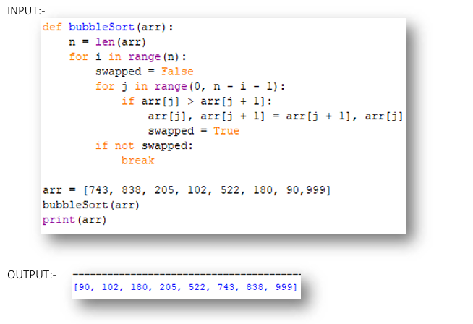
- Insertion Sort
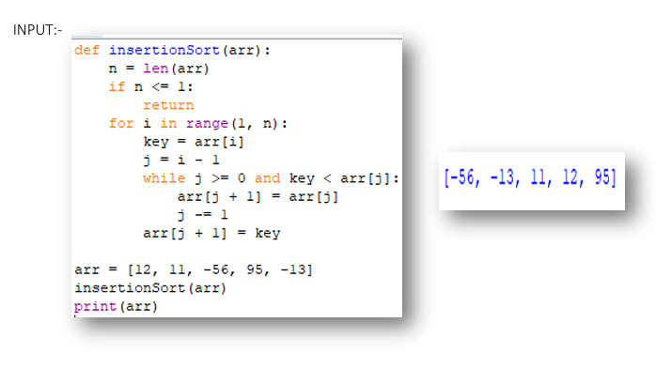
- selection Sort
